GOOD PRACTICE WHEN WORKING WITH YOUNG PEOPLE

England Lacrosse provides a range of good practice guidance for working with young people in several areas including:

General do’s and don’ts
Additional vulnerability
Position of trust
Supervision and communication, including social media
Changing rooms
Transport
Sources of other best practice guidance

GOOD PRACTICE WHEN WORKING WITH YOUNG PEOPLE DO’S AND DON’TS

England Lacrosse acknowledges that good practice when dealing with young people is essential. All people working with young people are expected to adhere to the following guidelines.

DO:

- Always be publicly open when working with young people. Ensure that whenever possible there is more than one adult present during activities with young people, or at least that you are in sight or hearing of others.
- Manual support is rarely required in the sport of lacrosse. If an adult feels that it is necessary the reasons should be clearly explained to the young person, and if possible, the parents/carers, and their consent gained. Be aware that any physical contact with a young person may be misinterpreted.
- Treat all young people with respect.
- Provide an example of good conduct you wish others to follow
- Respect a young person’s right to personal privacy, encourages young people and adults to feel comfortable and caring enough to point out attitudes or behaviour that they do not like.
- Remember that someone else might misinterpret your actions, no matter how well intentioned.
- Be aware that some young people are additionally vulnerable, this could be due to several factors including disability, sexual orientation, their elite status, language culture
- Challenge unacceptable behaviour and report all allegations/suspicions of abuse.

DO NOT (EXCEPT IN AN EMERGENCY)

- Spend excessive amounts of time alone with young people away from others
- Take young people alone on car journeys, however short
- Take young people to your home where they will be alone with you.

If cases arise where these situations are unavoidable, they should occur only with the full knowledge and consent of the young person’s parents. Where someone has had to act outside England Lacrosse guidance in an emergency, this should be reported to your Welfare Officer.

You should never:
- Engage in rough, physical, or sexually provocative games
- Allow or engage in any inappropriate physical or verbal contact with young people
- Allow young people to use inappropriate language unchallenged
- Make sexually suggestive comments to a young person, even in fun
- Allow allegations of a young person to go unchallenged, unrecorded, or not acted upon
- Do things of a personal nature for young people that they can do for themselves
- Invite or allow young people to stay with you at your home unsupervised
- Allow any form of bullying or bad behaviour by young people
- Allow yourself to be drawn into inappropriate attention-seeking behaviour or make suggestive or derogatory remarks or gestures in front of young people.
- Jump to conclusions about others without checking first
- Either exaggerate or trivialise child abuse issues

You should give guidance and support to inexperienced helpers.

If you accidentally hurt a young person, the young person seems distressed in any manner, appears to be sexually aroused by your actions, or misunderstands or misinterprets something you have done, report any such incident as soon as possible to another colleague and make a brief note of it. Parents or guardians should be informed of the incident.

It is strongly recommended that you do not work completely alone with groups of young people. Enlist the support of others – assistants, parents/carers.

This guidance is in addition to England Lacrosse’s Code of Ethics and Behaviour, go to
www.Englandlacrosse.co.uk/safeguarding

Safeguarding Young People with additional vulnerability

The following young people may be additionally vulnerable:
- Deaf and disabled participants
- Young athletes from minority ethnic communities
- Those who do not speak England as a first language
- Elite athletes
- Young lesbian, gay and transgender athletes

The reason that these young people have increased vulnerability is:
- Increased likelihood of social isolation
- Few outside contacts than other young people
- Dependency on others for practical assistance in daily living
- Impaired capacity to resist, avoid or understand abuse
- Speech and language to tell others what is happening
- Limited access for someone to discuss to
- Particular vulnerability to bullying

What makes young elite athletes vulnerable?
- More intense, dependant relationship with coach
- Higher stakes – for young person and family
- More away, overnight trips and travel abroad
- Less family and social / other support network
- Relatively isolated

FURTHER INFORMATION: Go to www.englandlacrosse.co.uk
England Lacrosse has policies on: -
- Equality
- Transgender

The CPSU has a DVD resource entitled: ‘Including deaf and disabled young people in sport’ - Go to www.thecspu.org.uk

Positions of trust

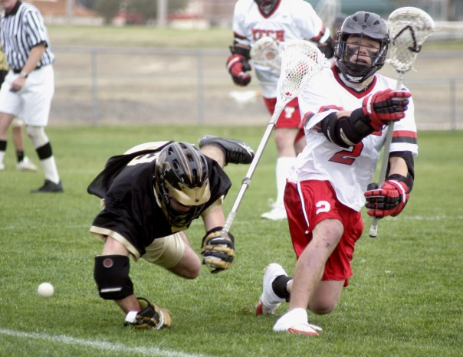
All adults who work with young people in lacrosse are in a position of trust, which has been invested in them by parents, the sport, and the young person. This relationship can be described as one in which the adult is in a position of power and influence by their position.

Positions of trust in lacrosse will include young leaders, coaches at all levels, captains, Team Manager, umpires, referees, coaches, and mentors. This list is not exhaustive

Within lacrosse, most adults in a position of trust recognise that there are certain boundaries in their relationship with a young person that must not be crossed in terms of the relationship with the young player. The relationship is no different to that between a schoolteacher and the pupils in their care. Adults must not encourage a physical or emotionally dependant relationship to develop between the person in a position of trust and the young person in their care.

All those within the club have a duty to raise concerns about the behaviour of any member of the lacrosse community which may be harmful to the young people in their care, without prejudice to their own position.

SEXUAL ACTIVITY
Within sport, as within other activities, sexual relationships can and do occur. All members of the lacrosse community must be aware of the law relating to sexual behaviour and observe England Lacrosse’s Code of Ethics and Behaviour.
Inappropriate or criminal sexual behaviour committed by young people may result in disciplinary action as well as being investigated under local authority safeguarding procedures for children and young people who sexually abuse.
Sexual relationships between adults and children under the age of 16 are illegal. Relationships between adults and young people over the age of 16 raise serious questions about the power imbalance inherent in the relationship. A coach or other adult in a position of authority has significant power over a young person’s career. Under the Sexual Offences Act 2003, this could constitute abuse of a position of trust and contravenes England Lacrosse’s Safeguarding Policy and Code of Ethics and Behaviour.
Inappropriate or illegal behaviour will lead to suspension and disciplinary action and will be referred to the Police/Children’s Social Care for investigation.

Supervision of Young People
Principles that underpin good practice for supervision of young people are as follows:

It is the responsibility of those commissioning, planning, or providing sessions/activities to ensure that those running the activity are suitable to do so. For example:

- They have undertaken an appropriate recruitment and selection process, this may include a DBS check (depending on the role)
- They have insurance appropriate to the activity
- They have adopted and are implementing codes of conduct
- They have an appropriate qualification for the activity
- They understand their responsibility to safeguard children
- They undertake training appropriate to the role they are doing

Leadership, coaching and officiating awards create opportunities for young people to develop their coaching or technical skills and sense of responsibility. However, this should not result in these young people being given full or lead responsibility for managing groups of children. Under 18 coaches or officials should be in addition to those appropriate adults with responsibility for supervising the activity. The organisation’s duty of care and Safeguarding and Protecting Young People policy extend to all under 18s, whether they are participants, coaches, or officials.

Whatever the recommended ratio of adults to participants is, a minimum of two adults should be present. This ensures at least basic cover in the event of something impacting on the availability of one of the adults during the activity (in the event of a participant requiring the attention of an adult during the activity following an accident for example).

In the planning of all activities, and regardless of any other assessments that may be required (for example of equipment or for Health and Safety purposes), a risk assessment should be undertaken which specifically informs decision-making about appropriate supervision levels.

Key factors to assess include:
- Age of children
- Additional supervision/support needs of some or all participants (for example due to disability)
- Competence/experience of participants for the specific activity
- Nature of activity
- Nature of venue (whether closed and exclusive, or open and accessible to members of the public).

Recommended minimum supervision ratios:
Children under 8 years old:
Based on government guidance for the provision of out of care childcare for children under 8 years old (Out of School Care: Guidance to the National Standards, OFSTED 2001 & the childcare act 2006)
One adult to 8 young people (with a minimum 2 adults)

Children over 8 years old:
One adult to 12 young people (with a minimum of 2 adults)

All clubs should have First Aid provision by ensuring:
- There is a qualified First Aider on site
- First aid boxes are up to date and accessible
- There is an AED available where possible
- There is access to a phone to contact the emergency services if required

Communication with Young People

When communicating with young people it is recommended that you:
- Contact players only when necessary
- If players need to be contacted urgently i.e., a change in training arrangement, set up a grapevine system
- Copy parents into written communication (i.e., letters or e-mails)
- Speak with a player and their parents if there is a need to communicate information in relation to playing, training or competition
- Clearly state the club’s policy on communication, including social media (see guidance below) with young people and their parents/carers

You should avoid:
- Contacting a young person unnecessarily
- Contacting young people by phone, text, or e-mail. This should never be undertaken without parental consent
- Emailing young people directly as individuals (can be done as part of a disclosed list, once permission is gained to do so)
- Using text as a medium of contact with a young person individually
- Making or receiving calls on a mobile phone during training or at competition (coach). It is inappropriate to compromise the safety of a session
- Emailing one young person without copying in parents, other players, or club members
- Allowing any young person to be part of your personal social networking sites.

DO’S AND DON’TS FOR THE USE OF SOCIAL NETWORKING SITES

England Lacrosse recognises the use of social networking sites to allow people to engage, connect and disseminate information virally to a network of individuals. Whilst these technologies provide exciting opportunities, if they are misused, they can have negative consequences. It is therefore important for anyone who has a position of trust over young people within lacrosse to consider their use of social networking sites.

The following are some guidelines to consider when using social networking sites

DO  Use social networking to engage your lacrosse club with young people.  Set up your club as a ‘Page’ rather than a personal profile  Consider the age of the people you will be interacting with (the minimum for most sites is 13)  Involve parents/carers with parental responsibility in communication with young people  Protect yourself, your privacy and all confidential information  Be clear to users what the site is and isn’t to be used for  Include good practice us a part of your club code  Promote positive communication  Ensure users are aware of the clubs reporting procedures  Ensure you are consistent in dealing with any inappropriate use  Always act in accordance with the England Lacrosse Safeguarding policy, procedures, and good practice guidelines | DON’T  Use a personal social network profile to engage with young people in lacrosse  Accept friend or follower request on your personal account if:  - You are in a position of trust in respect of that young person  - You hold a position of trust in the club  - Your contact with the young person is through the club and consent from the parent/carer has not been given  Post information that you don’t want everyone to see  Use social networking to abuse or criticise another club or association member  Use inappropriate language or humour, or ling to any unsuitable content  Use photos of young people without gaining written consent from the payer and parents/carers

Remember: THINK BEFORE YOU POST!
What is illegal offline is also illegal online

England Lacrosse provide additional guidance on social networking see “Think before you post”

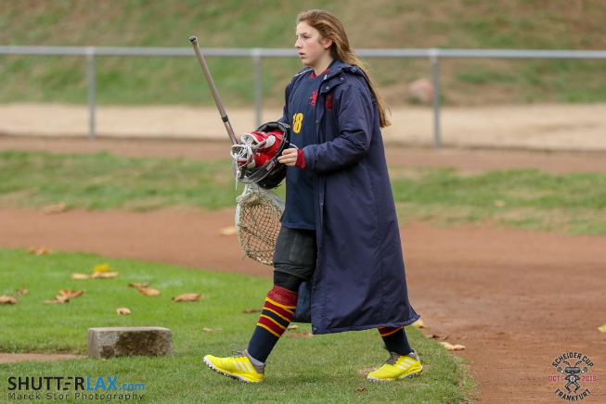

TRANSPORTATION
Dropping off and collecting young players at the club/training session

- Coaches and club staff will be responsible for young people in their care.
- It is the responsibility of parent/carer to transport their child/children to and from the club.
- It is not the coach or volunteer’s responsibility to transport young people to and from the club.
- The club must receive permission from parents/carers for young people to participate in all competitions and away fixtures/events.
- The club will provide a timetable of activities at the beginning of a season and notify parents/carers of any changes to this timetable in writing where practically possible.
- The club will require emergency contact numbers for parents/carers.
- The club adopts and publicises a late collection policy (see points in the right-hand column).
- The club will provide the parents/carers with a contact number, which may be used if the parent/carer will be late to collect their child/children.
- The club will ask parents/legal guardian to complete a form providing contact details, information about their child/children, i.e. medical details, etc.

Late collection
If a parent /carer are late, the club will:

- Attempt to contact the parent/carer
- Check the club contact number for any information regarding the young person
- Wait with the young person at the club, with wherever possible other staff/volunteers or parents
- Remind parents/carers of the policy relating to late collection
- Report the situation to Social Services or the Police if parents/carers remain uncontactable.

Staff/volunteers should avoid:

- Taking the child home or to any other location
- Asking the child to wait in a vehicle or the club with you alone
- Sending the child home with another person without permission.

Private cars
It is strongly advised that private cars, other than those of parents, are not used by coaches, club volunteers, team managers, and umpires to transport young players at any time, either to and from a training session, or to away fixtures. If for any reason this is the only feasible method of transport, the following guidelines must be followed:

- Drivers must ensure the safety of passengers
- Drivers must ensure that their vehicle is roadworthy and that they have a valid licence and insurance cover
- Drivers must only use vehicles with seat belts and ensure that their passengers are wearing these when in transit
- Drivers must be aware of their legal obligations when transporting young players
- Parents/guardians/carers must give written permission if their child/children are being transported in another adult car
- Clear information on the expected time of departure and arrivals needs to be communicated to relevant people, i.e., parents/guardians/carers
- Drivers should not be alone with a young person in the car at any time. If this situation arises, drivers need to ensure that the young person is in the back of the car

Hiring transport
When booking transport for an away fixture you will need to remember the following points:

- Passenger safety
- Competence of the driver and whether the driver holds an appropriate valid licence
- Number of driving hours for the journey and length of the drivers’ day including non-driving hours
- Whether more than one driver is required
- Type of journey, traffic conditions, weather, appropriate insurance cover
- Journey time, distance, and stopping points
- Supervision requirements
- Suitability of transport if the team includes disabled players
- Drivers will need to take breaks and be aware of emergency procedures

ADDITIONAL INFORMATION
The Child Protection in Sport Unit (CPSU) provide resources, videos, and best practice guidance on a range of subjects including: -

Self-Harm
Parental Behaviour
Spectator Behaviour
Safeguarding deaf and disabled children in sport (a multimedia learning resource)

Go to www.thecpsu.org.uk for more information

England Lacrosse’s Code of Ethics and Behaviour (Respect) go to www.englandlacrosse.co.uk/governance/respect

CHANGING ROOMS

The following guidelines should be adhered to:

- Players aged 10 and under must be supervised always in changing rooms by two members of staff of the same gender as the players
- Adults working with young teams, including volunteers, coaches, umpires, or staff, should not change or shower at the same time when using the same facility as young players

- Mixed gender teams must have access to separate male and female changing rooms (or arrange to use them at different times)

- If young players play for adult teams, they and their parents must be informed of the club’s policy on changing arrangements

- Young people are uncomfortable changing or showering in public, no pressure should be placed on them to do so. Encourage them to do this at home

- If your club has disabled players, involve them and their parents/carers in deciding how, if applicable, they wish to be assisted to change and ensure they provide full consent to any support or assistance required

- If you have young leaders (under 18) involved in running sessions for other young people it is not appropriate for them to change together (they are in a position of trust), make alternative arrangements for them to change (i.e. before/after other young people or change at home).

- If adults and young people need to share a changing facility, the club must have consent from the parents that their child/children can share a changing room with adults in the club


 